Dear Head Start champion,

Today, President Trump released his administration’s proposed budget for Fiscal Year 2026, which includes flat funding for Head Start, meaning our programs would be funded at the same level for the third straight year. The budget will go next to Congress for their consideration over the summer. While we are relieved that Head Start funding was not cut in a budget that makes deep cuts to critical non-defense discretionary programs, we must be clear: level funding is not enough.

As you well know, Head Start and Early Head Start grant recipients are facing substantial challenges. Rising operational costs, a national early childhood workforce crisis, and increasing needs among families have pushed many programs to the brink. Maintaining current funding levels without any adjustment for inflation or demand effectively amounts to a cut in real terms.

Without additional investment:
- Programs may be forced to reduce enrollment, shorten program hours, or cut critical services.
- Staff recruitment and retention will become even more difficult, further disrupting access and services for children.
- Eligible families in every state will feel the impact — especially those who rely on Head Start as their only pathway to early learning, health, and family support.
A few weeks ago, we faced a proposal that posed an even greater threat to Head Start. But we rallied, raised our voices, and stood together. Everyone who cares about Head Start spoke out — and we proved that when our community unites, we’re a powerful force. This latest budget proposal reflects that strength. It’s a step in the right direction and clear proof that our strategy is making an impact.

But we cannot stop now.

You can view my statement on the release of the budget as well as our LinkedIn message. Additionally, we encourage you to sign up for the eight-week summer action campaign: Project STAND FOR Head Start in honor of the launch of “Project Head Start” 60 years ago. These actions will make a deep impact!

Everyone knows that funding for Head Start is a wise and effective investment for children, families, and local communities. It’s up to us to keep ensuring our elected officials remember that.

We remain committed to standing up for you and fighting for the resources our children and families deserve.

In partnership,
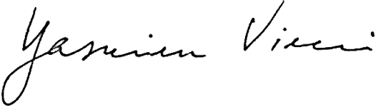
Yasmina Vinci
Executive Director
