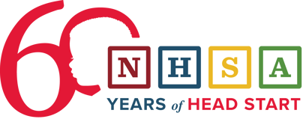
Today marks Head Start’s 60th birthday! From all of us at NHSA, thank you for your unwavering dedication to ensuring every child can reach their full potential, no matter their circumstances in life.

So, how can you celebrate this historic milestone?

Spread the Cheer with Our Birthday Song
Listen to “We Are Head Start,” composed by NHSA’s Rachel Hutchison and Nick “The Music Man” Young — and play it proudly wherever you are. If you’re attending the National Head Start Conference and Expo, sing along live with us as we celebrate together! Listen Now

Explore the Voices of Head Start
Explore our interactive map of oral histories from the Head Start community from 1965 to the present. Learn More

Protect and Strengthen Head Start
If you’re a Head Start parent, caregiver, or former Head Start student or family member, sign the letter to the president and Congress to protect this life-changing program. Sign Letter

Don’t stop there—urge your House member to sign the FY26 House Head Start support letter and remind your senators to protect Head Start and oppose any effort to eliminate or disrupt this life-changing program. Take Action

Sign the Birthday Card
Already signed it? Encourage others to do the same!

