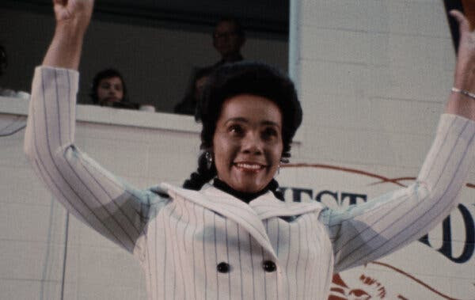

Coretta Scott King in the documentary “Nationtime.”Credit...Kino Lorber

By [Ben Kenigsberg](https://www.nytimes.com/by/ben-kenigsberg)

Feb. 26, 2025

*The proliferation of documentaries on streaming services makes it difficult to choose what to watch. Each month, we select three nonfiction films — classics, overlooked recent docs and more — that will reward your time.*

**‘Nationtime’ (1972)**

Stream it on the [Criterion Channel](https://www.criterionchannel.com/nationtime) and [Kino Film Collection](https://watch.kinofilmcollection.com/nationtime). Rent it on [Amazon](https://www.amazon.com/Nationtime-William-Greaves/dp/B08T6Q38FV/ref=tmm_aiv_swatch_0?_encoding=UTF8&sr=), [Apple TV](https://tv.apple.com/us/movie/nationtime/umc.cmc.6r2lqimmjhj5zmhji7adr5i6r), [Fandango at Home](https://athome.fandango.com/content/browse/details/Nationtime/1600476) and [Google Play](https://play.google.com/store/movies/details/Nationtime?id=nCg4gNTsPlY.P&hl=en_US).

In March 1972, William Greaves — the director of brain-twisting (and title-stretching) docu-fiction hybrid [“Symbiopsychotaxiplasm: Take 1”](https://www.nytimes.com/2005/10/26/movies/film-within-a-film-in-60s-time-capsule-groovy.html) (1968) — turned his camera on the National Black Political Convention in Gary, Ind., an event designed at least in part as a correlative to the conventions that the major parties would hold later that year. But the goal, as The New York Times [reported at the time](https://www.nytimes.com/1972/03/12/archives/-we-met-therefore-we-won-black-politics.html), wasn’t to nominate a presidential candidate. Instead, **the delegates in Gary sought to develop a vision to unify and increase political power for Black Americans**.

The gathering ended without a consensus, as the text preceding a [recent restoration](https://indiecollect.org/restoration/nationtime/) reveals. But the documentary, titled “Nationtime — Gary” onscreen, is a fascinating time capsule of a pivotal moment in Black American history. At the podium, a fiery Jesse Jackson says that he doesn’t trust white Democrats or white Republicans, and speaks of the short-lived promise of recent societal shifts. Black Americans may have won the right to go to any school, he says, but many lack the ability to pay tuition. (“When will we get paid for the work we have already done?” he asks the crowd.) At another point, the poet and playwright Amiri Baraka, who was one of the organizers of the convention and was then known as Imamu Amiri Baraka, speaks of how [Robert’s Rules of Order](https://www.nytimes.com/2007/05/20/books/review/Donadio-t.html) might not be followed as closely as in Congress. Rather, he says, the convention will run on “a thing called ‘African consensus’ that dated back a couple of thousand years before there was a Congress.” (Jackson credits Baraka with devising the delegates’ refrain: “What time is it? It’s nationtime.”)

Greaves highlights appearances by Betty Shabazz, the widow of Malcolm X; Coretta Scott King, the widow of the Rev. Dr. Martin Luther King Jr.; and the Black Panther leader and Chicago Eight defendant Bobby Seale. Later in the film, Greaves captures performances by the comedian Dick Gregory and the musician Isaac Hayes, who is onstage with Shaft himself, the actor Richard Roundtree. Harry Belafonte participates in the proceedings and contributes some of the documentary’s voice-over, reading poetry. Other narration is delivered by Sidney Poitier, who defines the significance of the three-day assembly as follows: “For the first time in Black political history, Black people were able to combine two distinctly different kinds of political power: the power of the ballot box and the power of protest groups.”

--

*“The problem is whether the American people have honesty enough, loyalty enough, honor enough, patriotism enough to live up to their own Constitution.”*

*Frederick Douglass*