All Newsletters | Read online

For subscribers | November 23, 2024

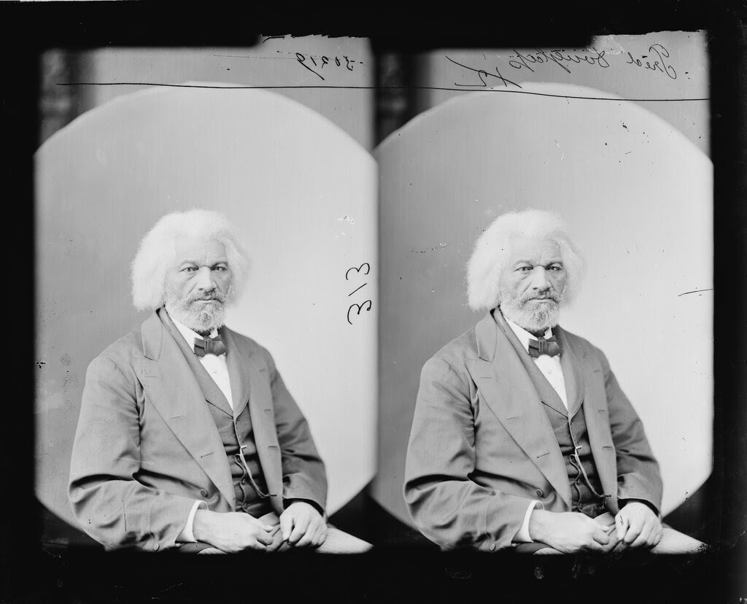
Brady-Handy photograph collection/Library of Congress
Most Americans who know of Frederick Douglass know that he lived to see the destruction of chattel slavery and the liberation of Black Americans from the despotism of human bondage. Less well known is the fact that Douglass would also live long enough to see the slave stand free, stand a brief moment in the sun, and move back again toward slavery, to paraphrase W.E.B. Du Bois in his book “Black Reconstruction.”
Douglass died in 1895 as the counterrevolution to Reconstruction and the agrarian rebellions of the 1880s and 1890s took final shape. In 1890, Mississippi imposed its Jim Crow Constitution. Other states in the South soon followed suit. In 1896, the Supreme Court would affirm “separate but equal” in Plessy v. Ferguson, a landmark ruling that would stand until 1954, when it was overturned by Brown v. Board of Education.
In 1894, at Metropolitan African Methodist Episcopal Church in Washington D.C., Douglass delivered the last great speech of his career. Titled “The Lessons of the Hour,” it was his attempt to make sense of the rise of Jim Crow and the violent retrenchment of the era. I want to share a little of the speech with you because I think it is worthwhile to read the perspective of someone who continues to fight for their ideals even in the midst of profound reversal and defeat.
Here’s Douglass, moving toward his conclusion.
I have sometimes thought that the American people are too great to be small, too just and magnanimous to oppress the weak, too brave to yield up the right to the strong, and too grateful for public services ever to forget them or fail to reward them. I have fondly hoped that this estimate of American character would soon cease to be contradicted or put in doubt. But the favor with which this cowardly proposition of disfranchisement has been received by public men, white and black, by Republicans as well as Democrats, has shaken my faith in the nobility of the nation. I hope and trust all will come out right in the end, but the immediate future looks dark and troubled. I cannot shut my eyes to the ugly facts before me.
He continues:
Strange things have happened of late and are still happening. Some of these tend to dim the lustre of the American name, and chill the hopes once entertained for the cause of American liberty. He is a wiser man than I am, who can tell how low the moral sentiment of this republic may yet fall. When the moral sense of a nation begins to decline and the wheel of progress to roll backward, there is no telling how low the one will fall or where the other may stop.
As much as Douglass intends to stand in the way of those would destroy the victory of an earlier age, he knows that, for him, “Time and strength are not equal to the task before me.” And yet:
But could I be heard by this great nation, I would call to mind the sublime and glorious truths with which, at its birth, it saluted a listening world. Its voice then, was as the trumpet of an archangel, summoning hoary forms of oppression and time honored tyranny, to judgement. Crowned heads heard it and shrieked. Toiling millions heard it and clapped their hands for joy. It announced the advent of a nation, based upon human brotherhood and the self-evident truths of liberty and equality. Its mission was the redemption of the world from the bondage of ages.
Douglass concludes:
Apply these sublime and glorious truths to the situation now before you. Put away your race prejudice. Banish the idea that one class must rule over another. Recognize the fact that the rights of the humblest citizen are as worthy of protection as are those of the highest, and your problem will be solved; and, whatever may be in store for it in the future, whether prosperity, or adversity; whether it shall have foes without, or foes within, whether there shall be peace, or war; based upon the eternal principles of truth, justice and humanity, and with no class having any cause of complaint or grievance, your Republic will stand and flourish forever.
I hope you find this as useful as I do.

