Can Upward Mobility Cost You Your Health?
By Gregory E. Miller, Edith Chen and GENE H. BRODY
January 4, 2014 2:30 pm January 4, 2014 2:30 pm 189

The Great Divide is a series about inequality.
Americans love a good rags-to-riches story. Even in an age of soaring inequality, we like to think that people can still make it big here if they work hard and stay out of trouble. The socioeconomic reality of most of the last four decades — stagnant wages, soaring income and wealth inequality, and reduced equality of opportunity — have dented, but not destroyed, the appeal of the American dream.
Those who do climb the ladder, against the odds, often pay a little-known price: Success at school and in the workplace can exact a toll on the body that may have long-term repercussions for health.
Among American children there are wide socioeconomic gaps on many dimensions of well-being: school achievement, mental health, drug use, teenage pregnancy and juvenile incarceration, to name just a few. Despite the risks that lower-income children face, we also know that a significant minority beat the odds. They perform admirably in school, avoid drugs and go on to college.
Psychologists refer to these children as resilient, because they achieve positive outcomes in adverse circumstances. They do so in part by cultivating a kind of determined persistence. Often with nurturing from a parent, relative or mentor, they set goals for the future, work diligently toward them, navigate setbacks, stay focused on the long term and resist temptations that might knock them off the ladder to success.
Several years ago, we began studying these resilient young people, trying to find out if their success stories also translated into physical health benefits. We reasoned that, if disadvantaged children were succeeding academically and emotionally, they might also be protected from health problems that were more common in lower-income youth. As it turned out, the exact opposite was true. These young people were achieving success by all conventional markers: doing well academically, staying out of trouble, making friends and developing a positive sense of self. Underneath, however, their physical health was deteriorating.
Our first hints of this pattern came from a study of 489 rural African-American young people in Georgia, whom one of us, Gene Brody, has been tracking for more than 15 years. Most came from families who were working but poor. In 2010, their average family income was about $12,000 a year; about half lived below the poverty line. We found a subgroup of resilient children who, despite these obstacles, were rated, at age 11, by their teachers as being diligent, focused, patient, academically successful and strong in social skills.
We followed these young people until they were 19 and studied their mental and physical health, focusing on depression, drug use, aggression and criminal behavior. As in past studies, those who were rated positively at age 11 had relatively few of these problems when they were 19. When we looked beneath the surface, though, these apparently resilient young people were not faring well. Compared with others in the study, they were more obese, had higher blood pressure and produced more stress hormones (like cortisol, adrenaline and noradrenaline). Remarkably, their health was even worse than peers who, at age 11, had been rated by teachers as aggressive, difficult and isolated. They were at substantial risk for developing diabetes or hypertension down the line.
Photo
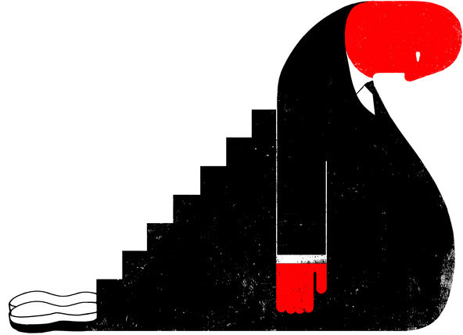
CreditEdel Rodriguez
We continued studying these youth as they transitioned into adulthood. Perhaps not surprisingly, the lower-income youth who made it to college used fewer drugs and drank less alcohol. To be academically competitive with their classmates, they had to stay focused on their schoolwork. As in the first study, though, their resilience was only skin deep. At age 20, the lower-income college kids had greater obesity, higher blood pressure and more stress hormones than those who did not make it to college. (Their health was also worse than that of peers in more affluent, educated neighborhoods.)
These patterns mesh with other social-science findings, which suggest that upward mobility does not always provide the expected “return on investment” when it comes to health. If we look at the life expectancy associated with a college education, blacks gain about four fewer years from bachelor’s degrees than do whites. In fact, black college graduates have shorter life expectancies than do white high school graduates.
What is it about upward mobility that undermines the health of these young Americans? In our studies, most participants are the first in their families to attend college. They feel tremendous internal pressure to succeed, so as to ensure their parents’ sacrifices have been worthwhile. Many feel socially isolated and disconnected from peers from different backgrounds. They may encounter racism and discrimination.
Some young people respond to the pressure by doubling down on character strengths that have served them well, cultivating an even more determined persistence to succeed. This strategy, however, can backfire when it comes to health. Behaving diligently all of the time leaves people feeling exhausted and sapped of willpower. Worn out from having their noses to the grindstone all the time, they may let their health fall by the wayside, neglecting sleep and exercise, and like many of us, overindulging in comfort foods.
Sherman A. James, a sociologist at Duke University, calls this single-minded determination to succeed and uncompromising work ethic, even in the face of overwhelming odds, “John Henryism,” after the legend of a black railroad worker who, in the 19th century, was said to have defeated a steam-powered drill in a steel-driving contest, only to drop dead of exhaustion. Mr. James has shown that lower-income African-American men who express these traits have a greater risk for hypertension as they age.
What can we do to mitigate these negative health effects? To start, schools and colleges that serve lower-income students could provide health education, screenings and checkups as a part of their curriculum. This would allow us to detect and address incipient health problems before they become serious. Second, schools and clinics could offer stress management programs, targeting lower-income, higher-achieving young people, to help them balance the competing demands on their minds and bodies.
Finally, we could develop programs to help these young people blow off steam in productive ways. We could pair them with mentors who have navigated similar life challenges and sponsor group physical activities. Of course, much more could be done: huge investments in primary education, so that kids have both the opportunity and preparedness to attend college, and face less social isolation, discrimination and alienation.
But for now, policy makers should do everything they can so that those young people who overcome so much to live the American dream have the health to enjoy the fruits of their efforts.

Gregory E. Miller and Edith Chen are professors of psychology and fellows of the Institute for Policy Research at Northwestern University. Gene H. Brody is professor of human development and family studies and the director of the Center for Family Research at the University of Georgia.

