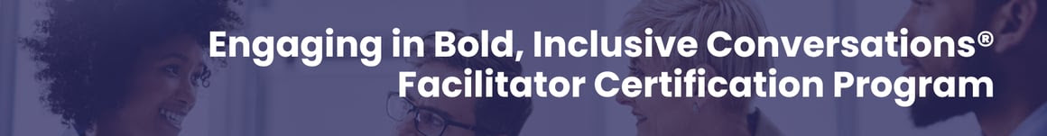
We are in a watershed, unprecedented time in the political history of the United States and, for that matter, the world.

The U.S. presidential election, regardless of political affiliation, will shift our day-to-day experiences as individuals, teams, and businesses. And you need to be proactive about how you and your organization will respond.

It's no longer a question of if you should be talking about politics at work. It's whether you are equipped with the competencies to have these conversations.

Mary-Frances Winters and Mareisha N. Reese literally wrote the book on how to talk about polarizing topics at work and how to foster empathy and belonging across differences. We turned these books into the award-winning Engaging in Bold, Inclusive Conversations® Facilitator Certification Program to give you the blueprint and tools for understanding the impact of the sociopolitical climate on the workplace and how to engage in cross-cultural conversations.

This program teaches you the skills to turn difficult conversations into breakthrough moments, the tools to create safe, brave spaces where people are seen and heard, and the confidence to do so.

Instead of avoiding, ignoring, or shutting down conversations, build your competencies to ensure that they are effective and that your team feels seen at work. Register now for our Engaging in Bold, Inclusive Conversations® Facilitator Certification Program happening virtually in September (last program of the year!).

Secure your spot in this program here

Our Engaging in Bold, Inclusive Conversations® Facilitator Certification Program was chosen as an Innovations in Diversity 2023 Award winner by Profiles in Diversity Journal. This award is for organizations creating effective programs aimed at fostering diversity, inclusion, and equity in the face of challenging, long-standing issues.

