Is your faith-based organization considering housing affordable development?
The rising tide of homelessness and the critical shortage of affordable housing underscore an urgent need for collective action, particularly within the faith community.
Join the Partnership for Faith-Based Housing & Community Development's Open House on Thursday, January 18th from 3-5pm to learn about one of the most crucial phases in the development process, pre-development. Also, learn how your congregation could be eligible for a forgivable pre-development loan of up to $30,000 for legal and technical assistance.
Registration for the Virtual Open House is free, and all are welcome to attend. Register online today at: bit.ly/46AFMCr

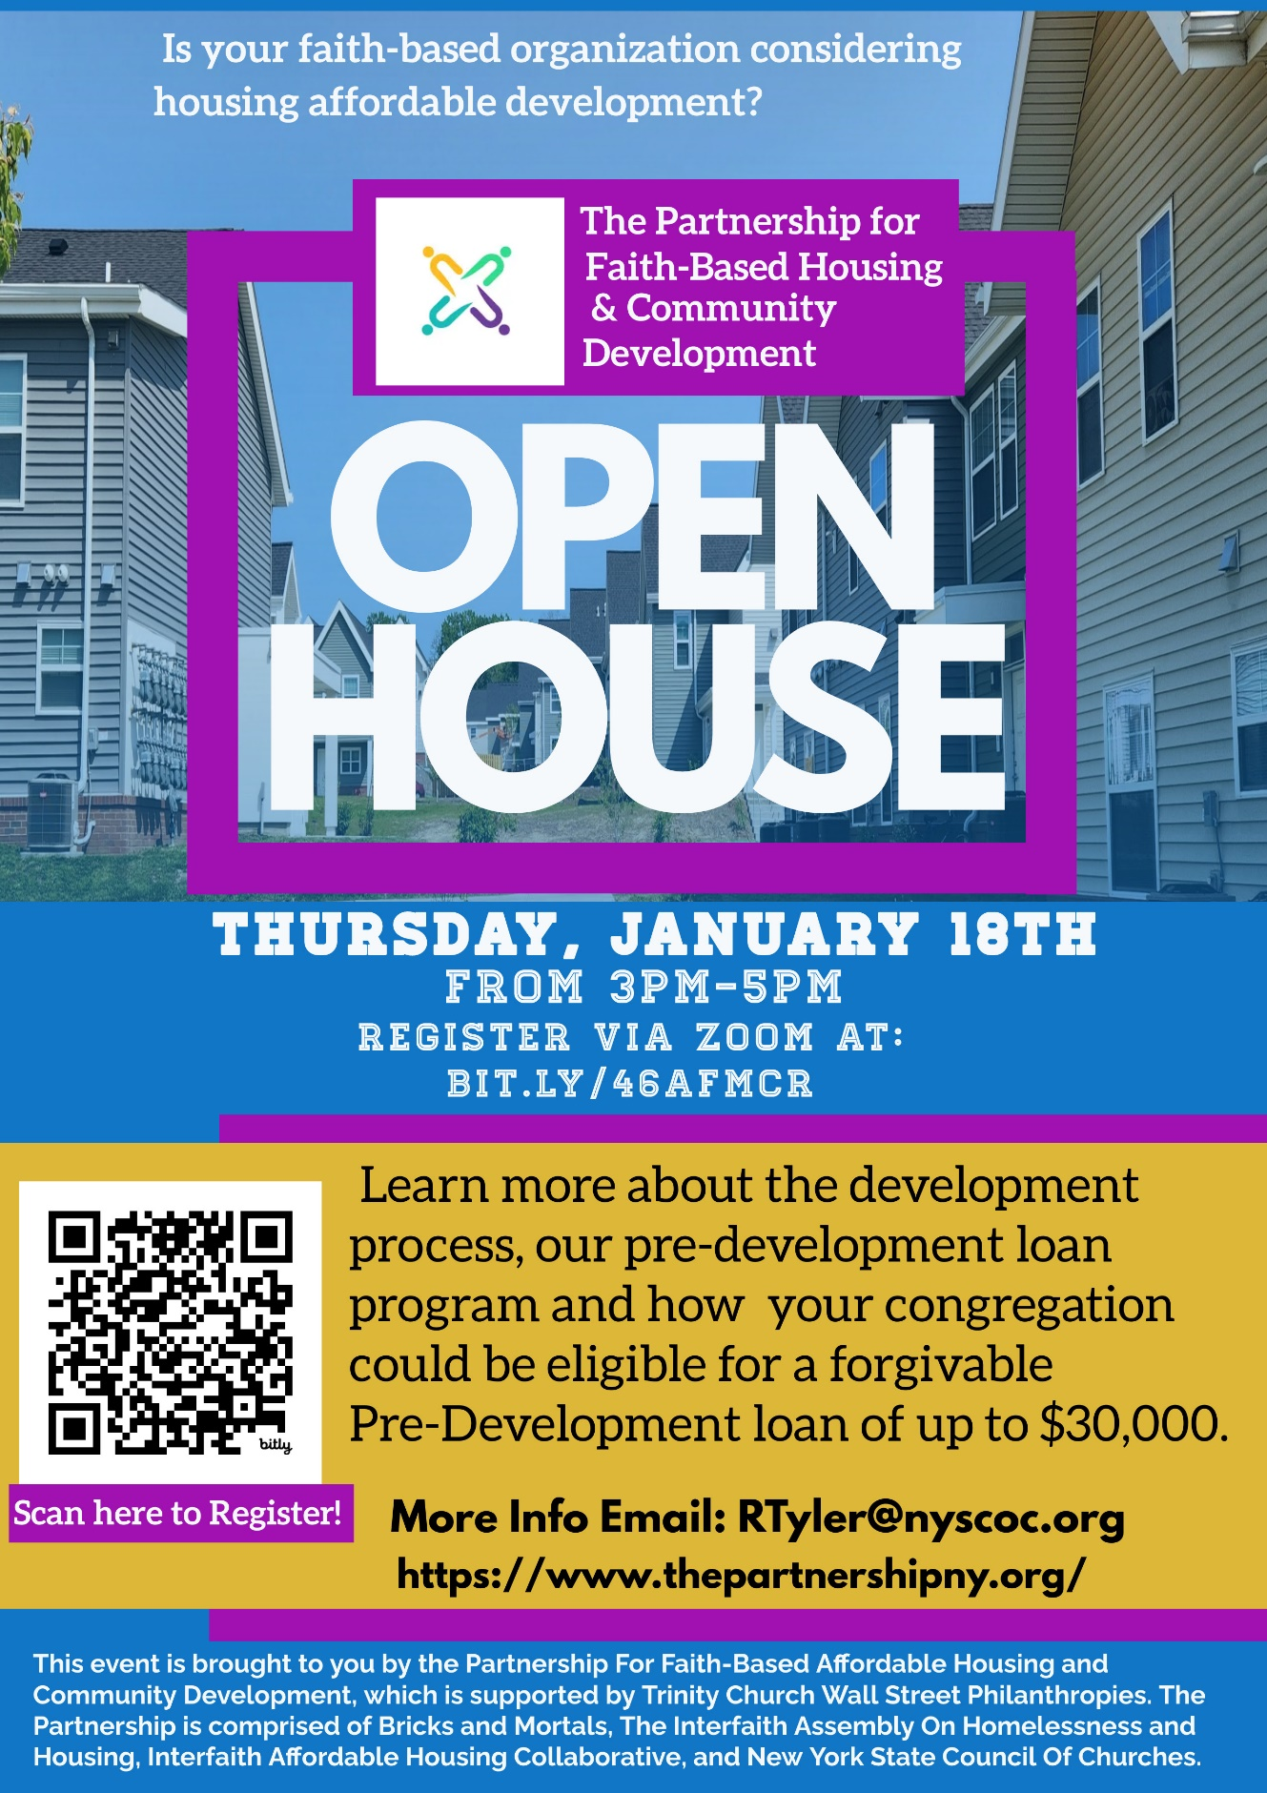

Join A NYS Council of Churches Social Justice working Group

Join the fight for social justice by joining one of the Council's dynamic working groups! Each group plays a pivotal role in shaping the legislative agenda and organizing educational seminars in their respective areas. There are five issue-area working groups you can join to work on statewide policies that will benefit your community: Immigration, Housing, Climate/Environment Justice, Wealth Inequality & Global Debt, Criminal Justice, Wages, and Union Labor. To get involved, simply click on the button below and complete the form, and the chair of your chosen issue-area working group will reach out to you. Join us in making a difference in the pursuit of justice and equity.

Join A Social Justice Working Group

January 18, 2024 3:00 PM - Virtual Open House with the Partnership for Faith-Based Housing and Community Development

