A City Sings for the Season 2023

December 3, 2023 | 4:00 PM ET
Stardust Ballroom at the Edgerton R Center
41 Backus Street, Rochester, NY 14608 (map)
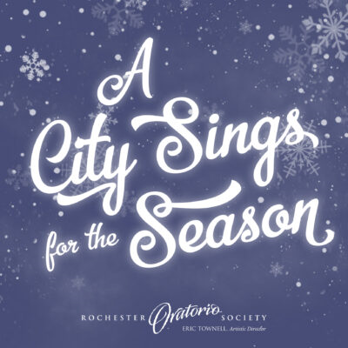
A free performance of holiday music and dance featuring:
Hochstein Youth Singers
ROC music Collaborative
Cameron Capoeira
Spiritus Christi Mass Choir
The Rochester Oratorio Society Chorus
Donations of food, clothing, and personal care items accepted at the door benefit Action for a Better Community.
Co-sponsored by the City of Rochester, NY.

