National Hispanic Heritage Month Celebration
Saturday, September 30
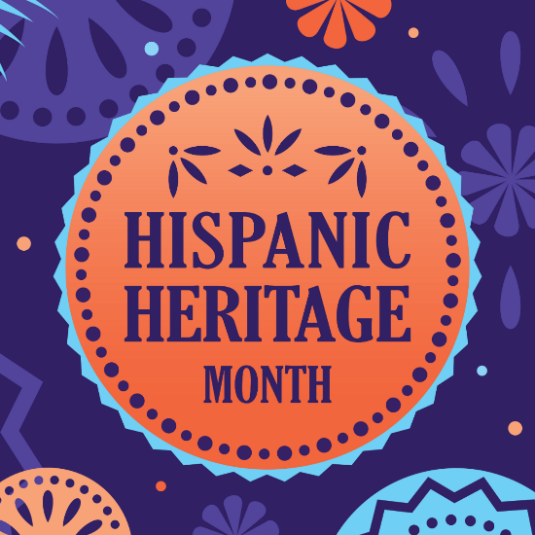
Celebrate National Hispanic Heritage month. Enjoy dance performances by Boriguen Dance in the Paychex Theater at 11:30 a.m. and 1 p.m. Make your own percussion instrument inspired by the Quijada from Peru. Also, view a cooking demonstration inspired by Latin American recipes, provided by the American Dairy Association North East.

National Hispanic Heritage Month Celebration is presented by the American Dairy Association North East.

