Beyond The White Fragility Echo Chamber
with Nanette D. Massey
Sunday April 23rd, online
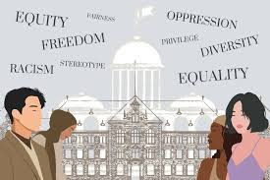
"Affirmative Action"
I﻿ started this online discussion series because I found e-v-e-r-ybody's got a lot of feelings when it comes to race, especially affirmative action. So much of those feelings are completely lacking in facts and recent history ("what's slavery got to do with today?"). We'll talk about the history of race and college acceptance in the US using the superbly researched book by Jerome Karabel, The Chosen: The History Of Admission And Exclusion At Harvard, Yale, And Princeton. I promise you'll find out some stuff you didn't know that'll change the context of how you see the June Supreme Court decision.

Register HERE | $ at-will donation $
3:00 pm ET | 2:00 pm CT | 1:00 pm MT | 12:00 pm PT

The book "White Fragility" has become a cultural touchstone for our time. Most U.S. white people, though, report having no regular contact with non-white people and can only discuss race in an "echo chamber" of other white frames of reference.--Internet webinar technology to the rescue! With black workshop facilitator Nanette D. Massey of Buffalo, N.Y., this is your chance to contextualize race from an unfiltered, real world experience rather than theory. With frankness and practicality, Massey's goal is to leave audiences with self-clarity and the ability to participate in conversations within their own personal spheres of influence with genuine confidence, humor, and humility.

Check out more of my work at NanetteDMassey.com and on YouTube.

