From: Bishop William J. Barber, II and Rev. Dr. Liz Theoharis, Poor People’s Campaign <info@breachrepairers.org>
Date: Fri, May 19, 2023 at 9:07 AM
Subject: Demanding an End to Policy Murder
To: <wewynne1@gmail.com>

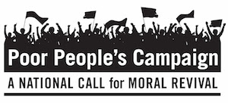

William,

Across the country, the Poor People's Campaign is calling for a Third Reconstruction. Amid targeted extremist attacks, murder exacted through public policy, and the interlocking injustices of systemic racism, ecological devastation, the war economy & militarism, and the distorted moral narrative of religious nationalism that have led to poverty becoming the 4th leading cause of death, we must rise together.

Last year, we released A Poor People’s Pandemic Report: Mapping the Intersections of Race, Poverty, and COVID-19, which collected data on poverty, income, and occupation as they relate to the COVID-19 pandemic. We found that poor and low income communities experienced higher death rates and infections of COVID-19 as a result of public policy failure to protect and support those experiencing interlocking injustices stemming from public policy.

And just a few weeks ago, researchers at the University of California, Riverside identified poverty as the fourth-greatest cause of death in the United States. That means in 2019, poverty silently killed 10 times as many people as homicides. Poverty is lethal. “Poverty kills as much as dementia, accidents, stroke, Alzheimer's, and diabetes," said David Brady, a professor of public policy at the University of California, Riverside of the study.

We cannot accept inaction towards poverty and policy murder in the richest nation to ever exist. For that reason, we launched the Poor People’s Campaign on Mother’s Day in 2018. As we reflect on our fifth anniversary, we recognize the strides we have made while acknowledging that our work is far from over.

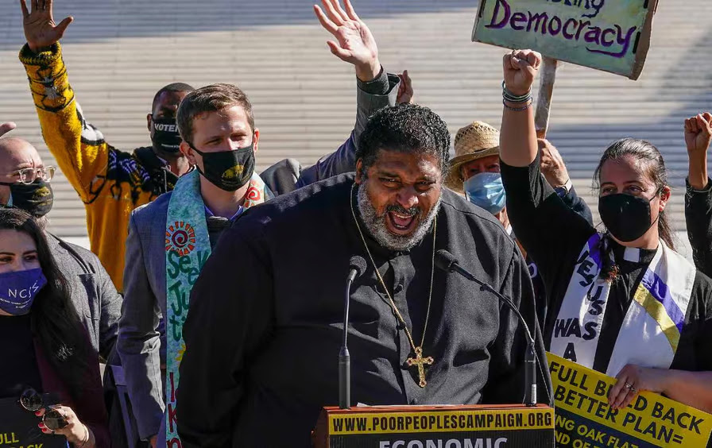

Across the country, over 35 state campaigns led by poor and directly impacted leaders, religious leaders, and advocates are mobilizing and organizing towards the Moral Poverty Action Congress in Washington D.C.

Together, we must continue raising demands to end poverty and low wages from the bottom up. Together, we will usher in a new era of moral revival.

Forward Together, Not One Step Back,

Bishop William J. Barber, II

National Co-Chair of the Poor People's Campaign, President & Senior Lecturer of Repairers of the Breach

Rev. Dr. Liz Theoharis

National Co-Chair of the Poor People's Campaign, Director of Kairos Center for Religions, Rights, and Social Justice

Make a Donation

Thank you for your generous contribution and continued support. With your gift, the Poor People’s Campaign: A National Call for Moral Revival can continue to build a broad, fusion movement that can unite poor and impacted communities across the country.

The Poor People's Campaign
3041 Broadway, Box 47
New York, NY 10027

Sent via ActionNetwork.org. To update your email address, change your name or address, or to stop receiving emails from A Poor People's Campaign: A National Call for Moral Revival, please click here.

