NATIONAL & WORLD AFFAIRS Here’s a radical suggestion: Stop simplifying Black women

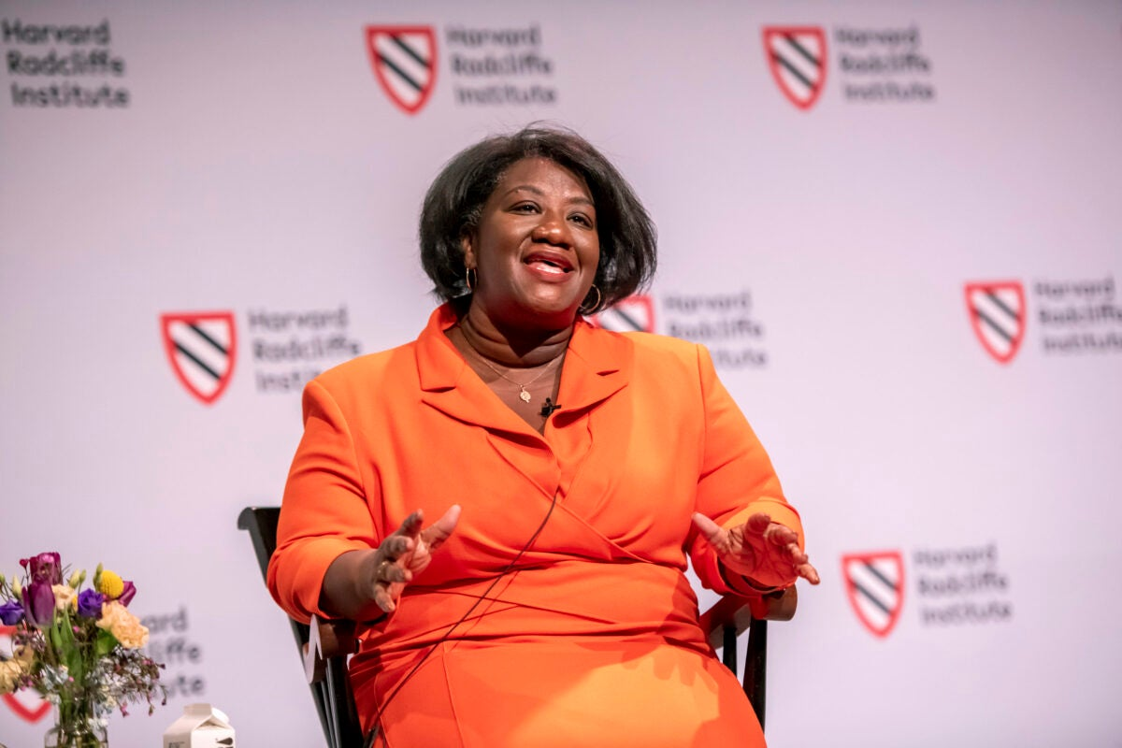
When asked about the state of American culture, Tressie McMillan Cottom said the sociological reality of being Black in America today is “empirically better than it has historically ever been …” But there is still so much inequality at play, she added.
Jon Chase/Harvard Staff Photographer

Sociologist, columnist Tressie McMillan Cottom explores complexities of race, class, politics (and problem with TikTok) at Radcliffe talk
BY Samantha Laine PerfasHarvard Staff Writer
DATEApril 6, 2023
SHARE
- Email
- Facebook
- Twitter
- LinkedIn

TRENDING

Kenneth C. Griffin makes gift of $300 million to FAS

Good genes are nice, but joy is better

Take it from the experts, a pet can change your life

Date set for Claudine Gay’s inauguration

Scars remain a decade later

Tressie McMillan Cottom says that first and foremost, conversations around Black women must begin with the understanding that they are both rational and human. Yet the spaces where they are treated as such are limited.
McMillan Cottom, a sociologist and professor at the University of North Carolina at Chapel Hill, made the observation last week as part of the Kim and Judy Davis Dean’s Lecture in the Social Sciences series at Harvard Radcliffe Institute. To warm applause and a handful of shy cheers, she took the stage for a wide-ranging discussion with Radcliffe Dean Tomiko Brown-Nagin.
“It’s very much a radical notion, and I use the word ‘rational’ quite deliberately,” said McMillan Cottom, who is also a 2020 MacArthur Fellow and New York Times columnist. The “political subjectivity” of Black women — how they understand the power dynamics in society — is often assumed to be rooted simply in a “politics of grievance” and dismissed. This serves to perpetuate stereotypes of what they care about; it downplays their experiences and contributions rather than allowing space for their nuanced stories and views.
As an example, she pointed to the social media movement “Trust Black Women.” Even in this effort to empower individuals, there’s an attempt by some to simplify the experience of all Black women into one perspective and to use that as a stand-in for Black politics generally.
“I think people take [that] literally, whatever Black women say, believe them. Which in and of itself is flattening. That’s to say what? Black women can’t be wrong? Black women can’t change their minds?” McMillan Cottom said. “How I understand it is that, no, trust that Black women have a perspective of the world.” That doesn’t mean they can’t be wrong or ill-informed; but treat Black women with the same critical rigor given to anyone. “If you do that, I think you become a better actor in our current environment,” she said. “I also think you become a better interpreter of the social environment and social reality.”
Throughout the event, Brown-Nagin asked McMillan Cottom pressing questions about the state of American culture, about how it has changed, and not.
At one point Brown-Nagin asked about McMillan Cottom’s grandmother, whom McMillan Cottom references in her work and prompts reflection by asking herself: Why me and not my grandmother? Cottom said that the sociological reality of being Black in America today is “empirically better than it has historically ever been” (a fact that, she notes, “some people find depressing”). But there is still so much inequality at play. She tries to hold both of those truths at once, and thinking about her grandmother allows her to do that.
“She used to say to me, ‘What are you, little girl?’” she said fondly, getting chuckles from the audience. “She could not imagine my life. And at the same time, she could imagine the constraints on my choices.” Her grandmother may not have understood the rigors of getting tenure, but she did understand Black women’s difficulty trying to keep their jobs.
Her grandmother also faced other hurdles, McMillan Cottom said. Society often views qualities such as intelligence, beauty, or skills as fixed and objective when they actually shift with changing cultural priorities and values. When she thinks of her grandmother, she knows that she was equally — arguably more — creative and smart, yet the structure of society at the time presented no opportunities for people like her to advance and thrive.
“I could be as individually ambitious and talented as I wanted to be, and if the structure had not imagined the possibility of me, it wouldn’t have mattered,” she reflected on her career. “I like to keep that in mind because I don’t want the lack of my imagination to make someone else impossible.” She notes that in current discourse, trans children seem to exist in this particularly vulnerable space.
Brown-Nagin and McMillan Cottom also explored subjects sometimes written off as unimportant or unserious: “beauty, style, popular culture.” Brown-Nagin asked why some critics struggle to accept that they matter.
“Ooh, I like this question, I think, but that means I could get in trouble,” McMillan Cottom said with a smile, leading to laughs from the audience.
McMillan Cottom said that whether we like it or not, we are aware that how something looks or is portrayed matters a lot in power hierarchies. One challenge is that these power dynamics are often portrayed as something “frivolous,” like hair color or fashion, but “what that is that we’re talking about is the aesthetics of power.”
She said that many refuse to talk about physical attributes involved in the “aesthetics of power” because we don’t like to admit they have the level of influence that they do.
The two discussed a recent incident in which McMillan Cottom was temporarily banned from the social media platform TikTok for posting a video that went viral about blond hair as a particular racial signifier that carries a cultural cachet of superiority in many areas. (She later penned an essay in The New York Times about the experience.)
She said that she didn’t intend for the piece to rustle up such a response, but it struck a nerve. In many ways it revealed people are much more comfortable assigning blame to the random “boogeyman” of racism or patriarchy out there, rather than taking responsibility for their own role in perpetuating damaging power dynamics.
“Patriarchy isn’t somebody standing out there, the same way racism isn’t standing out there, classism isn’t standing out there. We remake those things every day in the things we do with and to each other,” she said.
One audience member asked her if she had advice for how Black women can stay true to themselves at large institutions where they are trying to spark change. McMillan Cottom responded by saying it’s part of “the great story” of being a small group of people trying to leave a big mark on the world.
“We are a big people who’ve done amazing things,” she said. “Take what works and leave what doesn’t … That includes the things that would make you over in the institution’s image in a way that separates you from the people and the places that you love — and love you back.”

