All are welcome!
The 1619 PROJECT
Slow - Read and Discussion Group
This book discussion is presented by the Town of Brighton’s IDEA Board
and co-presented by SUNY Empire State.
Join us for a slow-read and group discussion of the 1619 Project—a collection of 18 transformative essays that support the contention that African-American enslavement is the cornerstone of the historical development of our life today: our founding documents, economic and financial institutions, political and cultural practices, and racial problems all hark back to slavery. The 1619 Project is a significant addition to our understanding of ‘how we got where we are’ and where we can go.
Co-Facilitated By: Sue Barocas and Susan Boland
Sessions begin on March 1st, 2023. Please register today.
Free, but registration is required
CLICK HERE TO REGISTER
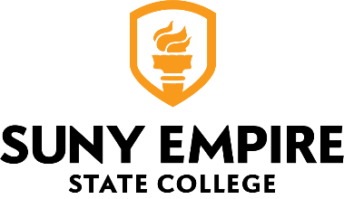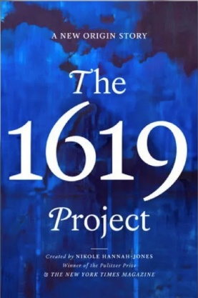

If you do not wish to receive further emails, click here to unsubscribe.
Questions? Call the Brighton Recreation Department at 585-784-5260
Register online at www.townofbrighton.org/rec
Like us on Facebook to follow program updates and upcoming events!

