November 2022
November 3 & 5 |  |  | Guest conductor Vinay Parameswaran leads the RPO in a program of Marsalis and Sibelius, with Violinist Tai Murry.
Tai Murry plays Winton Marsalis
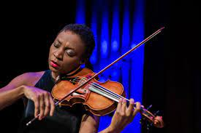 |  |  | 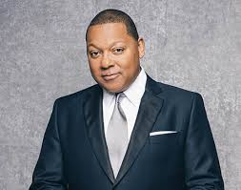
November 17 & 19 |  |  | Andreas Delfs leads the RPO in a program of Skye and Brahms. New work to feature soprano Jasmine Habersham.
World Premiere of new work by Derrick Skye
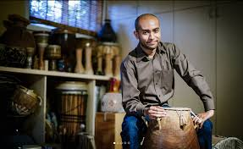 |  |  | 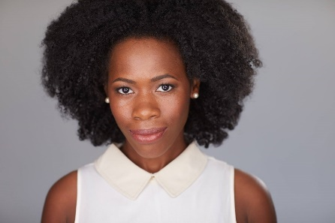
December 2022
December 16, 17, 18 |  |  | Conducted by Jeff Tyzik. Featuring All Star High School Chorus and guest vocalist Shayna Steele.
The RPO’s annual Gala Holiday Pops
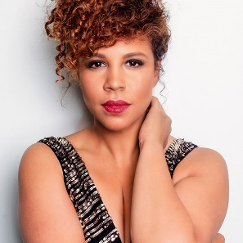
January 2023
January 20 & 21 |  |  | Frequent RPO guest conductor and performer Byron Stripling conducts music of Gershwin, Berlin & Friends, featuring Bassist and Jazz vocalist Nicki Parrott.
Byron Stripling returns
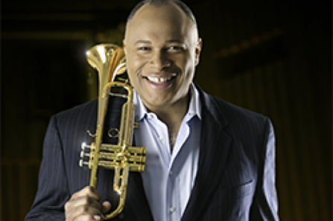
February 2023
February 9 & 11 |  |  | Jeff Tyzik conducts five works by Black Composers with links to Rochester and/or RPO history.
A Celebration of Black Composers
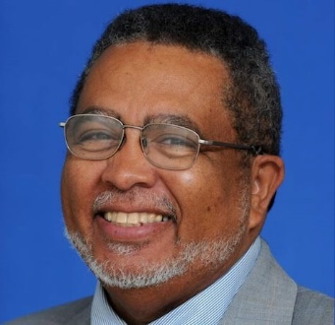 |  |  | First on the program is Rochester native Adolphus Hailstork’s An American Fanfare.
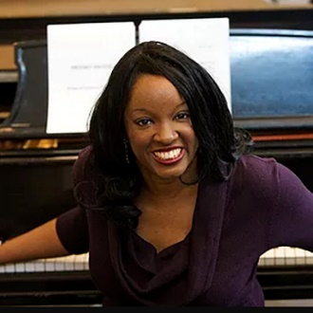 | 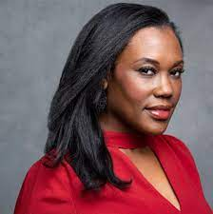 |  | Second is Nkeiru Okoye’s Songs of Harriet Tubman featuring Rochesterian Kearstin Piper Brow, soprano, taken from her Harriet Tubman opera When I Crossed that Line to Freedom.
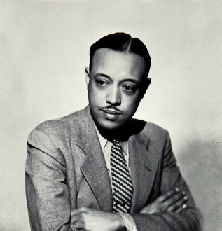 |  |  | Third is William Grant Still’s Afro American Symphony, premiered by members of the Rochester Philharmonic Orchestra conducted by Howard Hanson in 1931.
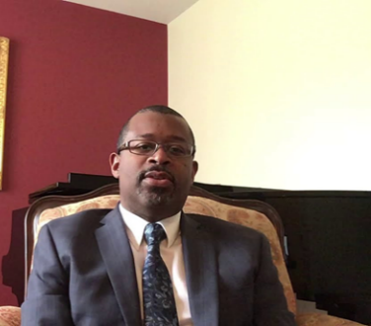 | 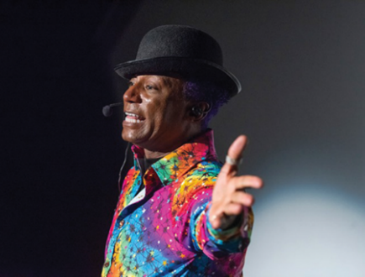 |  | Fourth is composer James Lee III new work Freedom’s Genuine Dawn, based on Frederick Douglass’ “What to the Slave Is the Fourth of July?” featuring Rochesterian Thomas Warfield as narrator. Co-commissioned by the RPO, the Boston Symphony Orchestra, and the Baltimore Symphony Orchestra.
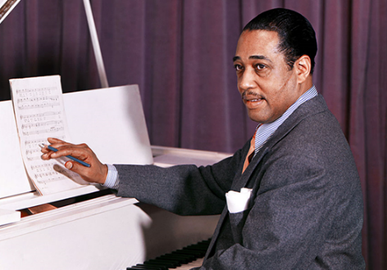 |  | 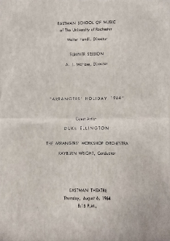 | The concert concludes with Duke Ellington’s The River Suite. Ellington performed with members of the RPO at the Eastman Theatre in August 1964.
March 2023
March 11 |  |  | Anthony Parnther, conductor.
Black Panther in Concert
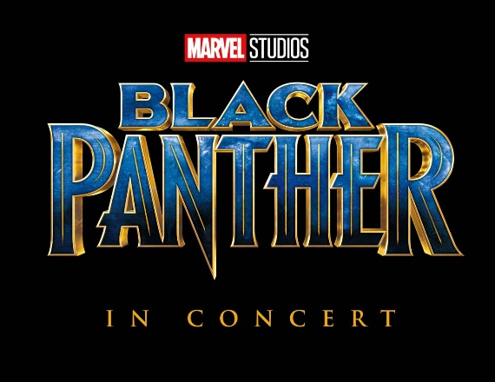 |  |  | 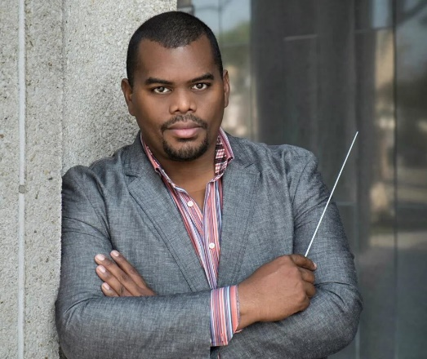
May 2023
May 18 & 19 |  |  | Andreas Delfs conducts Verdi’s Rigoletto, starring Lester Lynch and Raven McMillon.
The RPO’s annual Opera in Concert
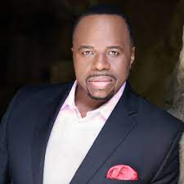 |  |  | 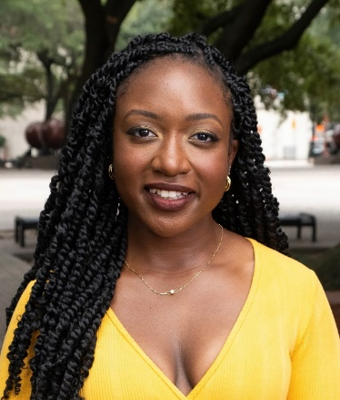
May 26 & 27 |  |  | Jeff Tyzik conducts Dancing in the Streets: The Music of Motown featuring Michael Lynche and Chester Gregory.
The RPO’s Pops series finale
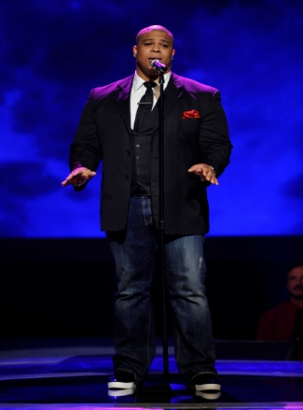 |  |  | 