This is a fantastic scholarship opportunity for those direct service providers who work in the I/DD community and others in the fields of mental and behavioral health who are pursuing or want to pursue a master's degree. Apply today!

Rochester Area Community Foundation
5d • 5 days ago

📣 Attention students working on graduate degrees in the fields of mental or behavioral health or developmental disabilities. Our Clark Family #Scholarship provides $60,000 annually to students pursuing master’s degrees in social work, nursing, OT/PT, HI/VI, psychology, health administration, and more. Get more information at https://bit.ly/3Zh46qg and apply before the Feb. 1 deadline.
#mastersdegree
#RochesterNY

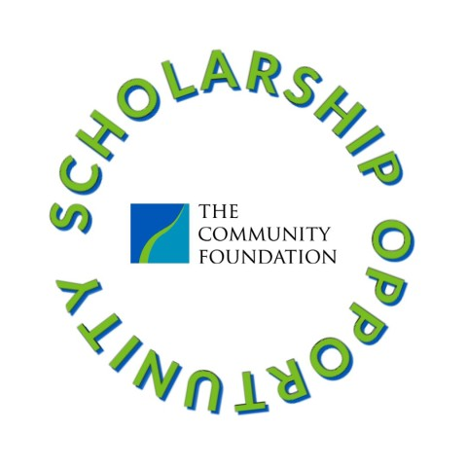

Clark Family Mental Health and Disability Scholarship - Rochester Area Community Foundation

