Beyond The White Echo Chamber with Nanette D. Massey
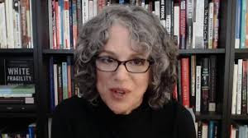
"Ask Me Anything"
Open Q&A with Robin DiAngelo
Sunday January 22, 2023 3pm EST
Robin DiAngelo, writer of White Fragility: Why It's So Hard For White People To Talk About Racism, is MY guest speaker AGAIN on Zoom taking questions directly from you. If you missed us last spring, here's your chance. A rare opportunity. Register below, and send your questions to NanetteDMassey@gmail.com.

Register HERE | $ at-will donation $
3:00 pm ET | 2:00 pm CT | 1:00 pm MT | 12:00 pm PT
Join African American writer Nanette D. Massey of Buffalo, NY, for the Sunday webinar series Beyond The White Echo Chamber, using ideas from Robin DiAngelo's bestselling book, White Fragility.
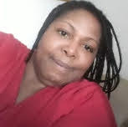 Check out my work at NanetteDMassey.com and on YouTube.

